Lake Washington Institute of Technology

Elec 211
Chapter 4

Jan 29th, 2017

Jim Burney

Elec 211, Chapter 4, Jan 29th, 2017, Jim Burney

Executive Summary – The goal for this lab was to work through chapter 4 in the book and try to complete the as much of the chapter that the software allows. I already knew that the timing section could be skipped, as the software does not support it at this time.
I followed the steps outlined in the chapter to understand how the software works.
By following the directions and programming the examples, I could easily follow what was going on.

Programming the majority volt logic on to the board.
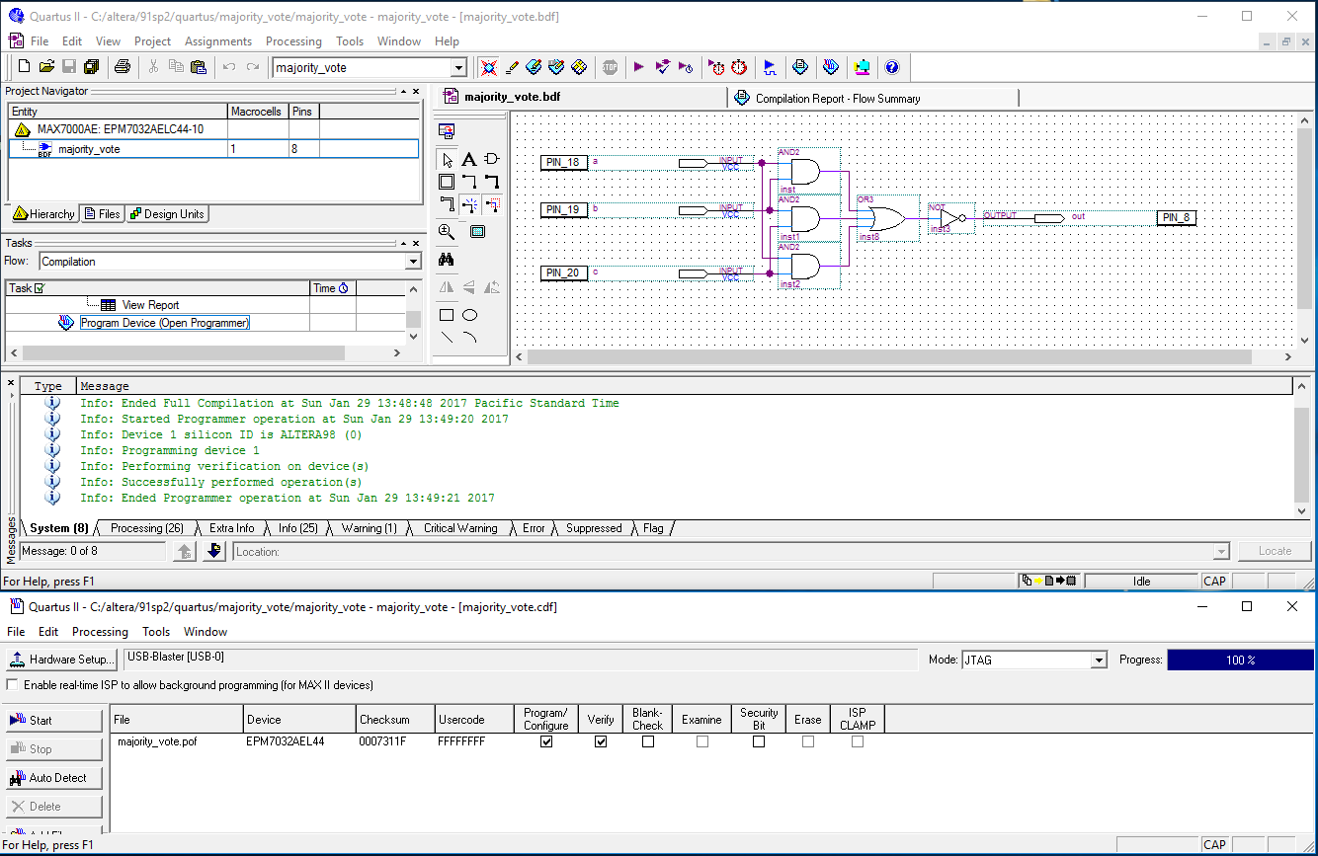

Elec 211, Chapter 4, Jan 29th, 2017, Jim Burney

For the next sections I did not to program the projects. I made the two-majority vote as pictured below.

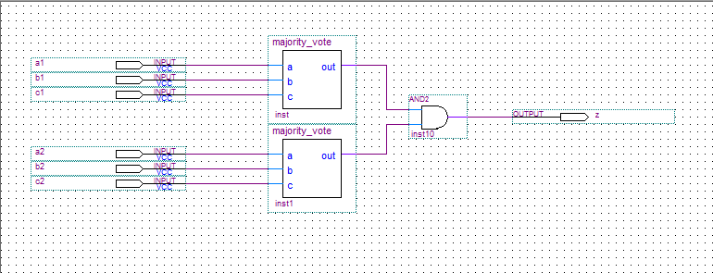

Then I made the two of the above majority votes to make the next one below.

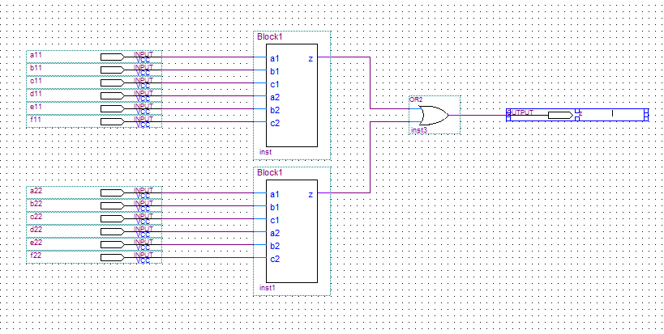

Elec 211, Chapter 4, Jan 29th, 2017, Jim Burney

